ERZ FAQs for Communities

What is the ERZ Program?
ERZ stands for Economic Revitalization Zone. The ERZ tax credit program, which is detailed in RSA 162-N, offers a short term business tax credit for projects that improve infrastructure and create jobs in designated areas of a municipality.

Why were ERZs established?
ERZs were established to stimulate economic redevelopment, expand the commercial and industrial base, create new jobs, reduce sprawl, and increase tax revenues within the state by encouraging economic revitalization in designated areas.

How is an ERZ defined?
An Economic Revitalization Zone, means a zone with a single continuous boundary, designated in accordance with the rules adopted under RSA 162-N:8, and having at least one of the following characteristics:
(a) Unused or underutilized industrial parks; or
(b) Vacant land or structures previously used for industrial, commercial, or retail purposes but currently not so used due to demolition, age, relocation of the former occupant’s operations, obsolescence, deterioration, brownfields, or cessation of operation resulting from unfavorable economic conditions either generally or in a specific economic sector.
A community must request that a site or contiguous area be designated as an ERZ by BEA. Each ERZ is evaluated every five years to assess whether the designation is still eligible.

How much is available for tax credits?
The State of New Hampshire designates $825,000 statewide, per year, to be available for ERZ tax credits.

How long will this initiative be in place?
This program will be in place until Jan. 1, 2028, or until the State law governing ERZs is repealed or amended.

What is the process to create an ERZ in the Community?

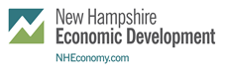

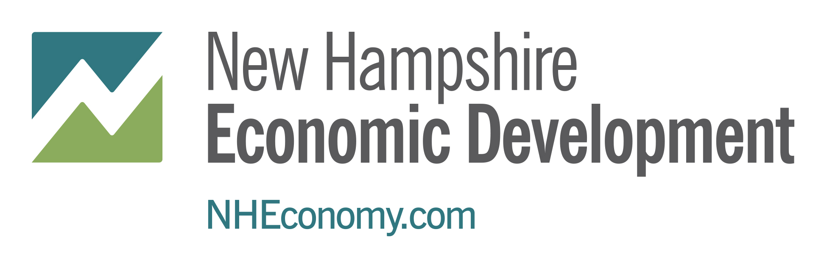
To apply for the tax credits a community must complete Form ERZ-1 available from the Department of
Business and Economic Affairs. The application must include reference to the public record of
acceptance by the governing body of the community.

How can a community benefit from ERZs?
Communities benefit from ERZs by the job growth of its businesses located in the community, and by potential growth of the local tax base due to expansion of the business’s plant and equipment assets. For a business to qualify for an ERZ tax credit it must invest in plant or equipment and create a least one (1) new full time job in the state, and meet the following criteria:

- The business must be physically located in an approved ERZ.
- Investment in plant or equipment must be made directly by the business applying for the ERZ tax credit.
- Jobs must be full time, direct employees, and not be contracted or “temp” jobs.
- The investment and the job creation must take place within one calendar year.

How is the credit calculated?
The credit is based on a percent of the salary for each new full time job created and the lesser of: either a percent of the actual cost incurred for the project or a maximum credit for each new job created in the fiscal year

What is considered a full time job?

A full time job is at least 35 hours per week and is a permanent, year-round position.

How can a business in the community claim the credit?

The deadline to apply is February 10th of the year following the applicant’s tax year. To apply for the tax credits an applicant must complete form ERZ-2 available from the Department of Business and Economic Affair’s website.

Who do I call with additional questions?
Contact the Division of Economic Development at (603) 271-2342.

